KINGSTON LAKE WOMAN’S AUXILIARY
ANNUAL WORKSHOP
10:00AM

April 15, 2023
Presiding, Sister Barbara D. Johnson, 1st Vice President
Theme: The Power of Faith: “Trusting Beyond Seeing”
Charge- Change Challenge

Devotional Services……………………………………Executive Board
District #1, District #2, District #3, District #4 & District #5

Greetings……………………………Sister Barbara Johnson
Selection…………………………Woman’s Auxiliary Choir
Offering/Offertory Prayer………………Finance Committee
Selection…………………………Woman’s Auxiliary Choir
Workshop Leaders
Senior Missionary………………………Rev. Hattie Graham
Youth………………………………… ..Sis. Barbara Smalls
(Classes will meet for 45 minutes and reassemble for Review)

Reviews

Election of Officers…………………Nomination Committee

Selection…………………………Woman’s Auxiliary Choir

Announcements

Remarks/Benediction……………………………….Minister
Workshop Notes
____________________________________________________________________________________________________________________________________________________________________________________________________________________________________________________________________________________________________________________________________________________
____________________________________________________________________
________________________________________________________________________________________________________________________________________
___________________________________________________________________
___________________________________________________________________
___________________________________________________________________
___________________________________________________________________
___________________________________________________________________
___________________________________________________________________
___________________________________________________________________
___________________________________________________________________
___________________________________________________________________
___________________________________________________________________
____________________________________________________________________
________________________________________________________________________________________________________________________________________________________________________________________________________________________________________________________________________________
___________________________________________________________________________________________________________________________________________________________________________________________________________________________________________________________________________________________________________________________________________________
_______________________________________________________________________________________________________________________________________________________________________________________________________________________________________________________________________________
____________________________________________________________________
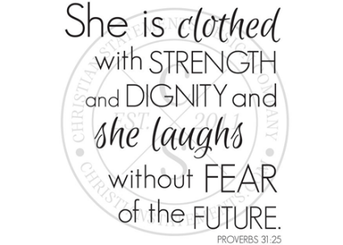
KINGSTON LAKE BAPTIST WOMAN’S AUXILIARY
Kingston Lake
Woman’s Auxiliary
Annual Workshop
April 15,2023

OFFICERS 2016-2020
President………………………………………………………………………………….Shirley Smith
1st Vice President…………………………………………………………….Barbara D. Johnson
2nd Vice President…………………………………………………………………….Angie Randall
Secretary……………………………………………………………………………….Linda H. Brown
Assistant Secretary…………………………………………………………………..Mary Colbert
Financial Secretary…………………………………………………………..Mary Alice Holmes
Treasurer…………………………………………………………………………….Vacant
Parliamentarian………………………………………………………………………Doris Hickman
Public Relations……………………………………………………………………………Lutie Floyd
Historian…………………………………………………………………………………Jeanette Faulk
Bible Teacher………………………………………………………..Evangelist Stephanie Long
Youth Advisor…………………………………………………………………………Barbara Smalls

EXECUTIVE BOARD MEMBERS
District #1………………………………………………………………………Carolyn G. Williams
District #2………………………………………………………………………….Thelma Galloway
Sarah Nell Chestnut
District #3………………………………………………………………………………………Hazel Bell
Hazel Jackson
District #4…………………………………………………………………………………Helen Bryant
Pinkie Patrick
District #5………………………………………………………………………………..Elouise Carter
Carolyn H. Williams

DISTRICT WORKERS
District #1………………………………………………………………………………Vacant
District #2……………………………………………………………………Min. Lynette Bratcher
District #3……………………………………………………………………………….Vacant
District #4…………………………………………………………………………….Sandra Williams
District #5…………………………………………………………………………………………..Vacant

May God continue to Bless and Keep you all, thanks
for making our Woman’s Auxiliary
Workshop a success!!!

Kingston Lake Education/Business Center
3410 Church Street
Loris, South Carolina 29569

Sis. Barbara Johnson, 1st Vice President
Sis. Angie Randall, 2nd Vice President
Linda H. Brown, Secretary

